The Deputy Manager,
Agro Industries,
Jammu and Kashmir.

No: KGP/Estt/2025-26/501 Dated:01-07-2025

Subject: Supply Order for Vermicompost and Flower Pots.
Dear Sir/Madam,
With reference to your proforma, we kindly request you to supply the following items to this Institution.
Items Required:
- Vermicompost 10 Kg bags - 5 Nos
- Flower Pots (12 Inches) - 4 Nos
- Flower Pots (14 Inches) - 2 Nos

Yours Faithfully
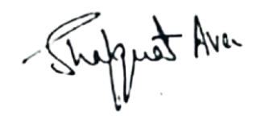
Principal
Kashmir Government Polytechnic College
Srinagar

